# Deakin College Information of Computing

**Assignment 2**

ID: JEOMD1702

Name: Munseong Jeong

Unit Code: SIT103

# Unit Name: Data and Information Management

Teacher: Alanni, Russul

Due Date: 18/january/2019

**DECLARATION**

I certify that the attached work is entirely my own (or where submitted to meet the requirements of a group assignment is the work of the group), except where work quoted or paraphrased is acknowledged in the text. I also certify that it has not been submitted for assessment in any other unit or course.

Student Signature: munseong jeong_____________ Date: 18/january/2019___________

# Question 1

1. Each student chooses up to 4 courses in one semester.
2. Each student chooses at least 2 courses in one semester.



1. Each teacher chooses up to 4 courses in one semester.
2. Each course maximum 200 students in one semester.
3. Each course 2 hours per day.
4. Each student applies for the course should before a unit start.
5. Each student can change courses within two weeks after the class.
6. Each student should grade over 50% to pass the course.
7. Each student’s attendance must be more than 80% for pass unit.
8. Each student cannot fail the same unit more than 3 times.

# Question 2



# Question 3



college(college_NO: string(10), name:string(50), dean:string(50), address:string(100))



grants(grant_NO:string(10), title:string(50), start_date:date, agency:string(50), college_NO:string(10))



support(grant_NO: string(10), start_date:date, end_date:date, principal_live: string(10), supports:string(50))



department(department_NO: string(10), college_NO: string(10), name:string(50), chairperson:string(50), telephone:string(20))



staff_department(staff_NO: string(10), department_NO: string(10))



staff(staff_NO: string(10), suname:string(50), given:string(50), security_number:integer, address:string(100), brith:date, rank:string(50), sex:chart(1), office_number:string(50), phone:integer, salary:integer)



committee(committee_NO: string(10), staff_NO: string(10), SID: string(10))



student(SID: string(10), surname:string(50), given:string(50), sex:chart(1), address:string(100), birth:date, class:integer, degree1:string(50), degree2:string(50))



section(section_NO: string(10), course_NO: string(10),staff_NO:string(10), SID: string(10), minar_department_NO: string(10), major_department_NO: string(10))



transcript(transcript_NO: string(10),section_NO:string(10), course_NO: string(10), SID: string(10), grade:integer)

course(course_NO: string(10), name:string(20),description:string(150), department_NO: string(10))

# Question 4

Q1:

--------------------------

DROP TABLE SUPPORT;

DROP TABLE GRANTS;

DROP TABLE TRANSCRIPT;

DROP TABLE SECTION;

DROP TABLE COMMITTEE;

DROP TABLE STUDENT;

DROP TABLE STAFF_DEPARTMENT;

DROP TABLE STAFF;

DROP TABLE COURSE;

DROP TABLE DEPARTMENT;

DROP TABLE COLLEGE;

-------------------------------

CREATE TABLE COLLEGE

(COLLEGE_NO VARCHAR2(10) PRIMARY KEY NOT NULL,

NAME VARCHAR2(50) NULL,

DEAN VARCHAR2(50) NULL,

ADDRESS VARCHAR2(100) NULL);

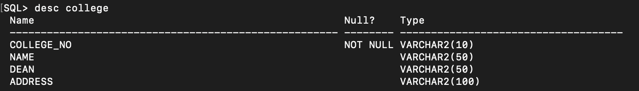

CREATE TABLE DEPARTMENT

(DEPARTMENT_NO VARCHAR2(10) PRIMARY KEY NOT NULL,

COLLEGE_NO VARCHAR2(10) REFERENCES COLLEGE(COLLEGE_NO),

NAME VARCHAR2(50) NULL,

CHAIRPERSION VARCHAR2(50) NULL,

TELEPHONE NUMBER(20) NULL);

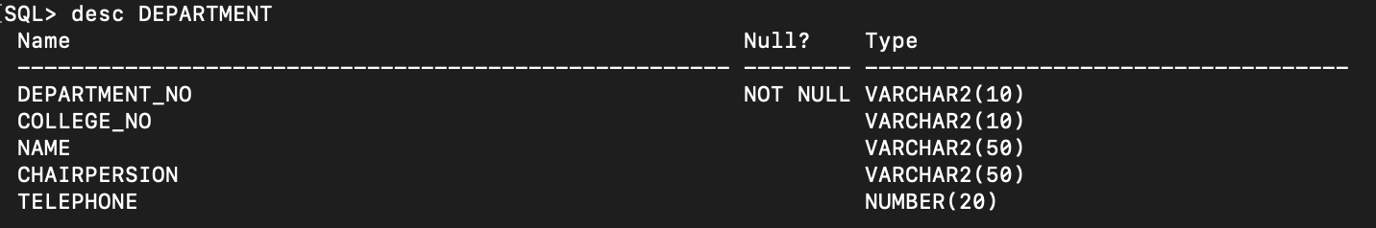

CREATE TABLE COURSE

(COURSE_NO VARCHAR2(10) PRIMARY KEY NOT NULL,

DEPARTMENT_NO VARCHAR2(10) REFERENCES DEPARTMENT(DEPARTMENT_NO),

NAME VARCHAR2(50) NULL,

DESCRIPTION VARCHAR2(150) NULL);

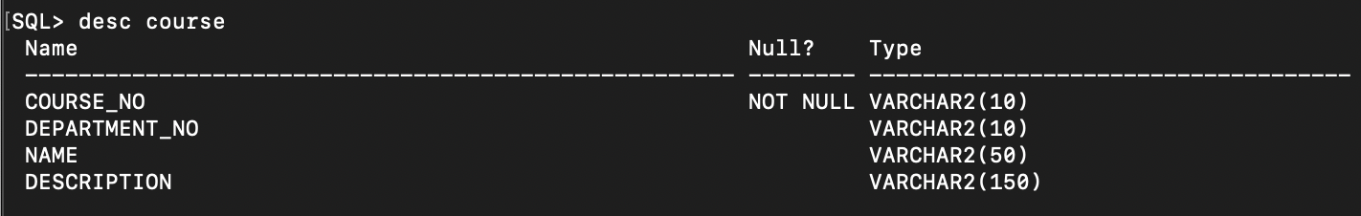

CREATE TABLE STAFF

(STAFF_NO VARCHAR2(10) PRIMARY KEY NOT NULL,

SURNAME VARCHAR2(50),

GIVEN VARCHAR2(50),

SECURITY_NUMBER NUMBER(20),

ADDRESS VARCHAR2(100),

BIRTH DATE NULL,

RANK VARCHAR2(50),

SEX CHAR(1),

PHONE NUMBER(20),

SALARY NUMBER(10));

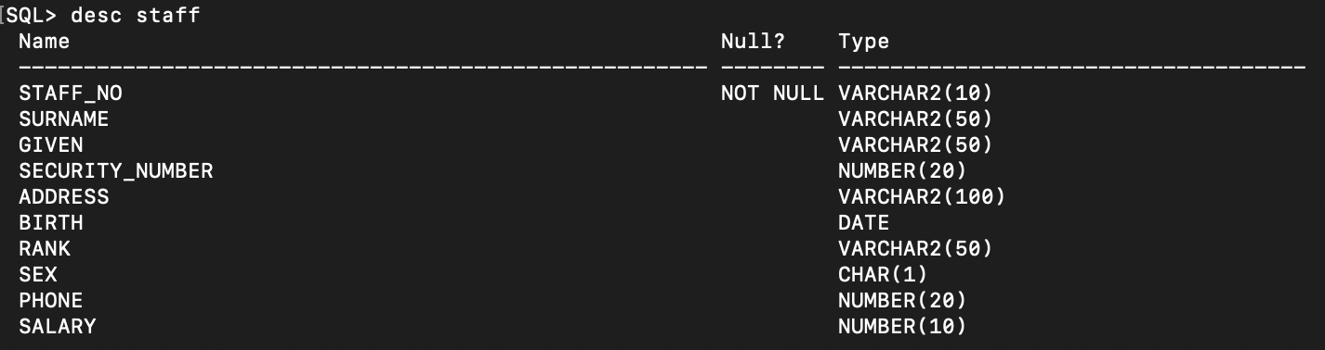

CREATE TABLE STAFF_DEPARTMENT

(STAFF_NO VARCHAR2(10) REFERENCES STAFF(STAFF_NO),

DEPARTMENT_NO VARCHAR2(10) REFERENCES DEPARTMENT(DEPARTMENT_NO));

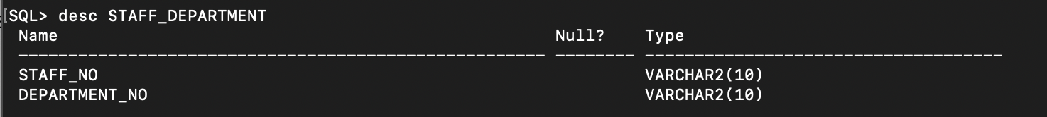

CREATE TABLE STUDENT

(SID VARCHAR2(10) PRIMARY KEY NOT NULL,

SURNAME VARCHAR2(50),

GIVEN VARCHAR2(50),

SEX CHAR(1),

ADDRESS VARCHAR2(100),

BIRTH DATE NULL,

CLASS NUMBER(1),

DEGREE1 VARCHAR2(50) NULL,

DEGREE2 VARCHAR2(50) NULL);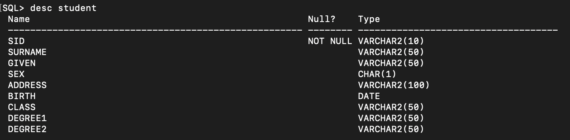

CREATE TABLE COMMITTEE

(COMMITTEE_NO VARCHAR2(10) PRIMARY KEY NOT NULL,

STAFF_NO VARCHAR2(10) REFERENCES STAFF(STAFF_NO),

SID VARCHAR2(10) REFERENCES STUDENT(SID));

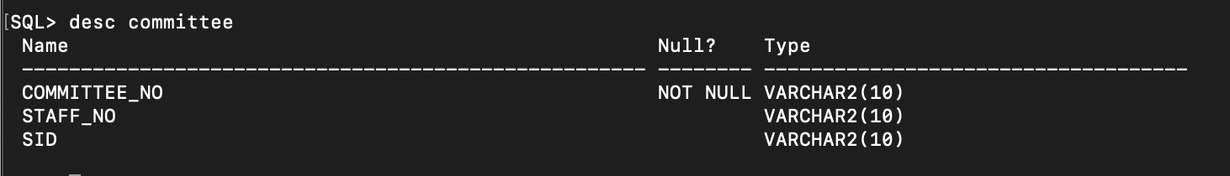

CREATE TABLE SECTION

(SECTION_NO VARCHAR2(10) PRIMARY KEY NOT NULL,

COURSE_NO VARCHAR2(10) REFERENCES COURSE(COURSE_NO),

STAFF_NO VARCHAR2(10) REFERENCES STAFF(STAFF_NO),

SID VARCHAR2(10) REFERENCES STUDENT(SID),

MINAR_DEPARTMENT_NO VARCHAR2(10) REFERENCES DEPARTMENT(DEPARTMENT_NO),

MAJOR_DEPARTMENT_NO VARCHAR2(10) REFERENCES DEPARTMENT(DEPARTMENT_NO),

YEAR DATE,

OFFER_YEAR DATE NULL,

QUARTER VARCHAR2(50),

QUARTER_NO NUMBER(1));

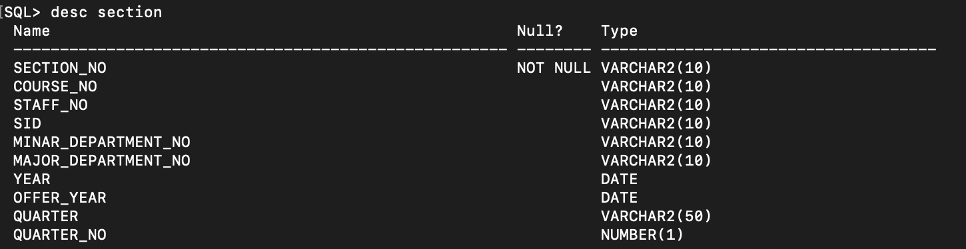

CREATE TABLE TRANSCRIPT

(TRANSCRIPT_NO VARCHAR2(10) PRIMARY KEY NOT NULL,

SECTION_NO VARCHAR2(10) REFERENCES SECTION(SECTION_NO),

COURSE_NO VARCHAR2(10) REFERENCES COURSE(COURSE_NO),

SID VARCHAR2(10) REFERENCES STUDENT(SID),

GRADE NUMBER(3) NOT NULL);

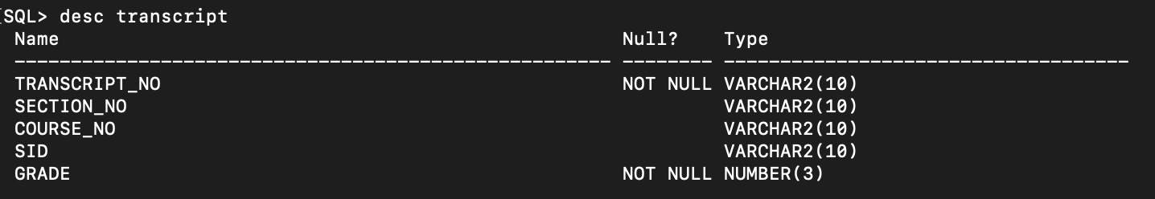

CREATE TABLE GRANTS

(GRANT_NO VARCHAR2(10) PRIMARY KEY NOT NULL,

TITLE VARCHAR2(100) NOT NULL,

START_DATE DATE NOT NULL,

AGENCY VARCHAR2(50),

COLLEGE_NO VARCHAR2(10) REFERENCES COLLEGE(COLLEGE_NO));

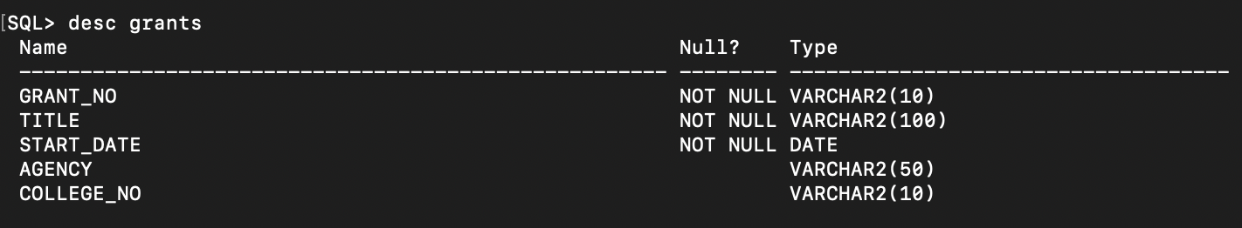

CREATE TABLE SUPPORT

(GRANT_NO VARCHAR2(10) REFERENCES GRANTS(GRANT_NO),

START_DATE DATE NOT NULL,

END_DATE DATE,

PRINCIPAL_INVE VARCHAR2(10) REFERENCES STAFF(STAFF_NO),

SUPPORT VARCHAR2(10) REFERENCES STUDENT(SID));

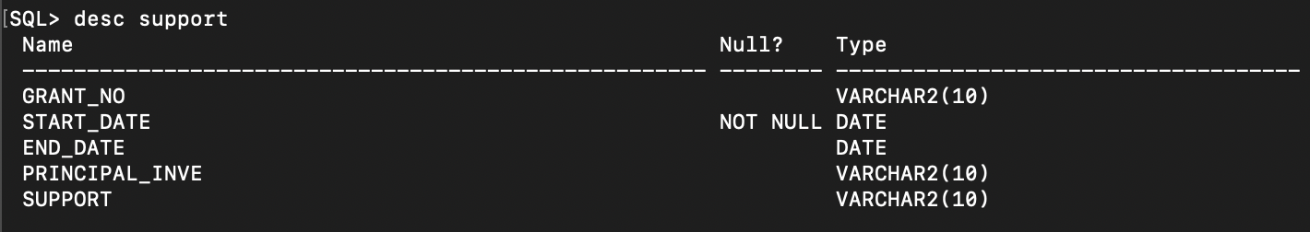

INSERT INTO COLLEGE VALUES('A0001', 'BURWOOD CAMPUS', 'MIKE', '28,NICE ROAD BURWOOD');

INSERT INTO COLLEGE VALUES('A0002', 'GEELONG CAMPUS', 'BOB', '18,BIG ROAD GEELONG');

INSERT INTO COLLEGE VALUES('A0003', 'MALASIA CAMPUS', 'JAK', '23,CAT ROAD MALASIA');

INSERT INTO COLLEGE VALUES('A0004', 'CHINA CAMPUS', 'LEON', '21,DOG ROAD CHINA');

INSERT INTO COLLEGE VALUES('A0005', 'KOREA CAMPUS', 'LEO', '51,COW ROAD KOREA');

INSERT INTO COLLEGE VALUES('A0006', 'USA CAMPUS', 'MARK', '23,BALL ROAD USA');

INSERT INTO COLLEGE VALUES('A0007', 'SYDNEY CAMPUS', 'JOBS', '75,BIRD ROAD SYDNEY');

INSERT INTO COLLEGE VALUES('A0008', 'CANADA CAMPUS', 'KATE', '35,TIFANY ROAD CANADA');

INSERT INTO COLLEGE VALUES('A0009', 'ITALIE CAMPUS', 'DIC', '96,ANGY ROAD ITALIE');

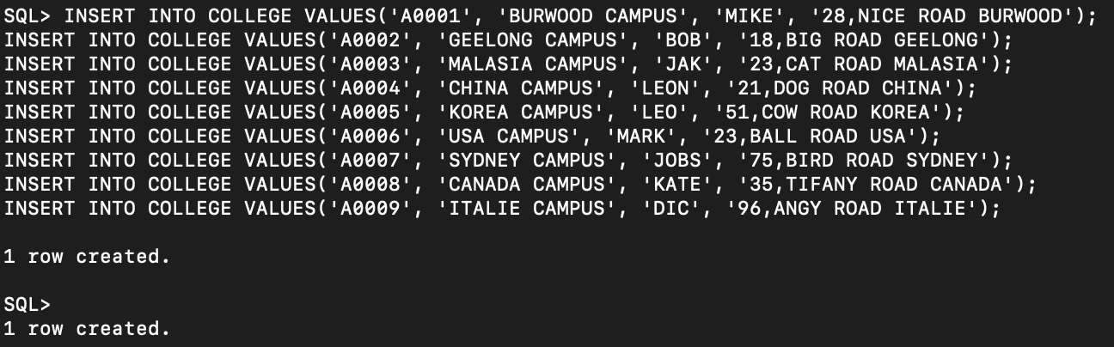

SELECT COLLEGE_NO,NAME, DEAN,ADDRESS FROM COLLEGE;

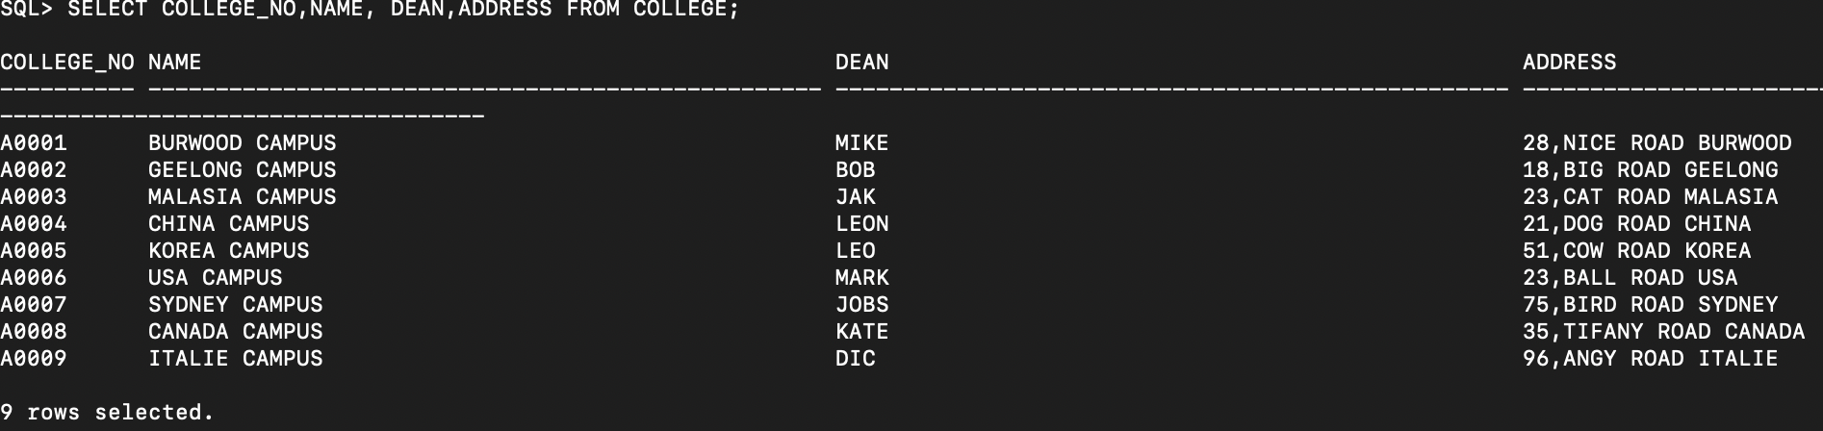

INSERT INTO DEPARTMENT VALUES('B0003', 'A0001', 'ACT DEPARTMENT', 'JOB', 130449214);

INSERT INTO DEPARTMENT VALUES('B0033', 'A0005', 'MATH DEPARTMENT', 'DAB', 2413123);

INSERT INTO DEPARTMENT VALUES('B0059', 'A0005', 'CHEMISTRY DEPARTMENT', 'DBO', 615523);

INSERT INTO DEPARTMENT VALUES('B0048', 'A0005', 'PHYSICAL EDUCATION DEPARTMENT', 'CC', 64364645);

INSERT INTO DEPARTMENT VALUES('B0027', 'A0001', 'MATH DEPARTMENT', 'KOC', 432342342);

INSERT INTO DEPARTMENT VALUES('B0016', 'A0007', 'PHYSICAL DEPARTMENT', 'LIDE', 66464);

INSERT INTO DEPARTMENT VALUES('B0065', 'A0007', 'ART DEPARTMENT', 'KMY', 6532464);

INSERT INTO DEPARTMENT VALUES('B0073', 'A0009', 'PHYSICAL DEPARTMENT', 'JB', 4562334);

INSERT INTO DEPARTMENT VALUES('B0082', 'A0009', 'CHEMISTRY DEPARTMENT', 'MUNSEONG JEONG', 130449214);

INSERT INTO DEPARTMENT VALUES('B0072', 'A0008', 'PHYSICAL EDUCATION DEPARTMENT', 'JOBS', 75566555);

INSERT INTO DEPARTMENT VALUES('C0011', 'A0002', 'COMPUTER SCIENCE DEPARTMENT', 'MUN', 75566555);

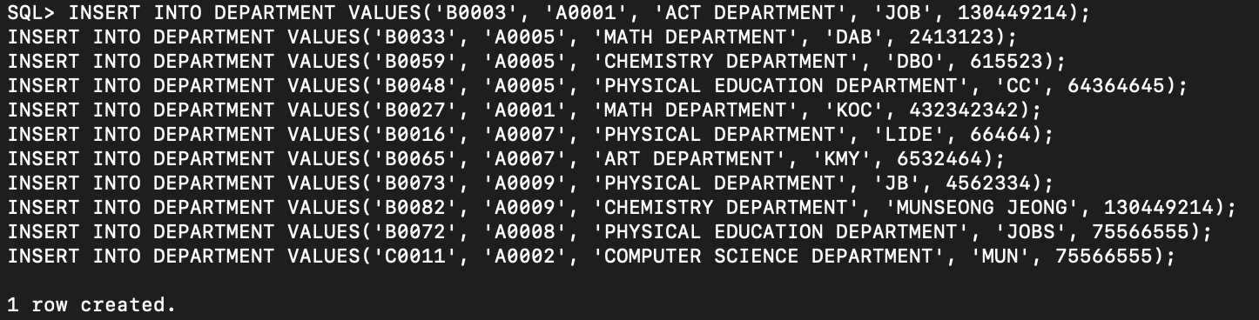

SELECT DEPARTMENT_NO,COLLEGE_NO,NAME,CHAIRPERSION,TELEPHONE FROM DEPARTMENT;

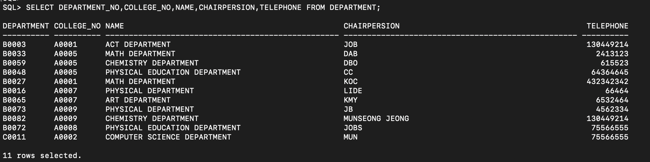

INSERT INTO COURSE VALUES('A103', 'B0003', 'PAINTING', 'PAINTING IS THE A BRUSH, BUT OTHER IMPLEMENTS, SUCAN BE USED. THE FINAL WORK IS ALSO CALLED A PAINTING.');

INSERT INTO COURSE VALUES('A104', 'B0033', 'PAINTING', 'PAINTING IS THE PRACTICE OFTS, SUCH AS KNIVES, SPONGES, AND AIRBRUSHES, CAN BE USED. THE FINAL WORK IS ALSO CALLED A PAINTING.');

INSERT INTO COURSE VALUES('PY105', 'B0027', 'PHYSICAL', ' PRACTICE OF APPLYING PAINT, PIGMENT, COLOR OR OTHER MEDIUM[1] TO A SOLID SURFACE (SUPPORT BASE). THE MEDINING.');

INSERT INTO COURSE VALUES('CHE302', 'B0003', 'CHEMISTRY', 'ED. THE FINAL WORK IS ALSO CALLED A PAINTING.');

INSERT INTO COURSE VALUES('CHE401', 'B0065', 'CHEMISTRY', 'EDIUM IS COMMONLY APPLIED TO THE BASE WITH A BRUSH, BUT OTHER IMPLEMENTS, SUCH AS KNIVES, SPONGES, AND AIRBRUSHES, CAN BE USED. THE FINAL WORK IS ALSO CALLED A PAINTING.');

INSERT INTO COURSE VALUES('PHY321', 'B0072', 'PHYSICAL', ' SOLID SURFACE (SUPPORT BASE). THE MEDIUM IS COMMONLY APPLIED TO THE BASE WITH A BRUSH, BUT OTHER IMPLEMENTS, SUCH AS WORK IS ALSO CALLED A PAINTING.');

INSERT INTO COURSE VALUES('TH231', 'B0033', 'PAINTING', ' HER MEDIUM[1] TO A SOLID SURFACE (SUPPORT BASE). THE MEDIUM IS COMMONLY APPLIED TO THE BASE WITH A BRUSH, BUT OTHER S, CAN BE USEING.');

INSERT INTO COURSE VALUES('TH201', 'B0033', 'PAINTING', ' MEDIUM[1] TO A SOLID SURFACE (SUPPORT BASE). THE MEDIUM IS COMMONLY APPLIED TO THE BASE WITH A BRUSH, BUTNTING.');

INSERT INTO COURSE VALUES('COM201', 'B0027', 'PHYSICAL', 'FACE (SUPPORT BASE). THE MEDIUM IS COMMONLY APPLIED TO THE BASE WITH A BRUSH, ALSO CALLED A PAINTING.');

INSERT INTO COURSE VALUES('COM213', 'B0003', 'CHEMISTRY', 'PDIUM IS COMMONLY APPLIED TO THE BASE WITH N BE USED. THE FINAL WORK IS ALSO CALLED A PAINTING.');

INSERT INTO COURSE VALUES('MAT221', 'B0065', 'CHEMISTRY', 'PAMEDIUM A PAINTING.');

INSERT INTO COURSE VALUES('MAT332', 'B0027', 'PHYSICAL', 'PAINTINGASE). THE ES, CAN BE USED. THE FINAL WORK IS ALSO CALLED A PAINTING.');

INSERT INTO COURSE VALUES('MAT331', 'B0027', 'PHYSICAL', 'PAINTINGASE). THE ES, CAN BE USED. THE FINAL WORK IS ALSO CALLED A PAINTING.');

INSERT INTO COURSE VALUES('MAT322', 'B0027', 'PHYSICAL', 'PAINTINGASE). THE ES, CAN BE USED. THE FINAL WORK IS ALSO CALLED A PAINTING.');

INSERT INTO COURSE VALUES('CS103', 'C0011', 'PHYSICAL', 'PAINTINGASE). THE ES, CAN BE USED. THE FINAL WORK IS ALSO CALLED A PAINTING.');

INSERT INTO COURSE VALUES('CS102', 'C0011', 'JAVA', 'code). THE ES, CAN BE USED. THE FINAL WORK IS ALSO CALLED A PAINTING.');

INSERT INTO COURSE VALUES('CS101', 'C0011', 'HTML', 'code). THE ES, CAN BE USED. THE FINAL WORK IS ALSO CALLED A PAINTING.');

INSERT INTO COURSE VALUES('CS104', 'C0011', 'DATABASE', 'code). THE ES, CAN BE USED. THE FINAL WORK IS ALSO CALLED A PAINTING.');

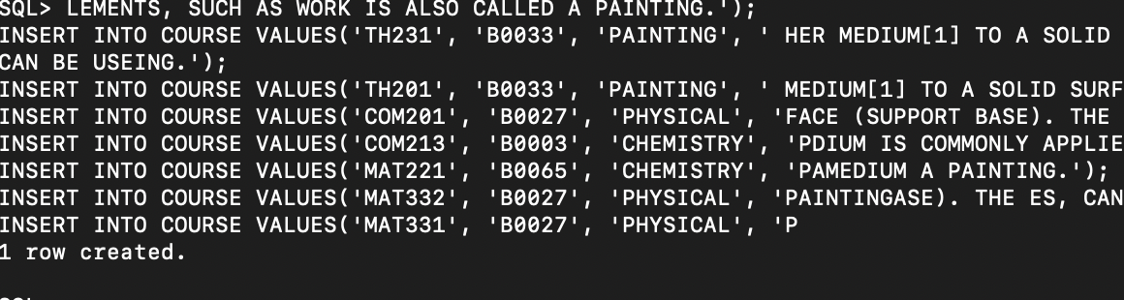

SELECT COURSE_NO, DEPARTMENT_NO, NAME, DESCRIPTION FROM COURSE;

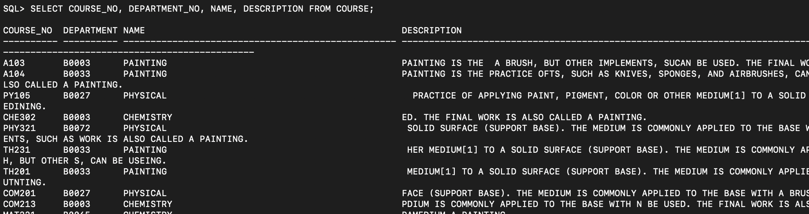

INSERT INTO STAFF VALUES('BOB1102', 'BOB', 'JO', 10322, '32 GOOD ROAD BURWOOD EATS MELBOURNE', '25-NOV-93','ASSISTANT','M', 04523213,5000);

INSERT INTO STAFF VALUES('DJW231', 'JOWING', 'MUN', 4123, '22 GOOD ROAD BURWOOD EATS MELBOURNE', '11-OCT-12','RESEARCH','F', 04523213,5020);

INSERT INTO STAFF VALUES('DSM1203', 'DYSM', 'MIN', 141512, '61 GOOD ROAD BURWOOD EATS MELBOURNE', '22-FEB-12','ASSISTANT','F', 04523213,5000);

INSERT INTO STAFF VALUES('KIS1702', 'KIM', 'SAM', 46432, '21 GOOD ROAD BURWOOD EATS MELBOURNE', '1-FEB-02','RESEARCH','M', 04523213,1000);

INSERT INTO STAFF VALUES('MKS1902', 'MAKEKYN', 'SHIN', 96242, '11 GOOD ROAD BURWOOD EATS MELBOURNE', '2-FEB-08','ASSISTANT','F', 04523213,50200);

INSERT INTO STAFF VALUES('IKS1602', 'ITALY KING', 'SAM', 73246, '73 GOOD ROAD BURWOOD EATS MELBOURNE', '2-JAN-03','ASSISTANT','M', 04523213,50040);

INSERT INTO STAFF VALUES('OLS1401', 'OKAN', 'LONG', 234623, '35 GOOD ROAD BURWOOD EATS MELBOURNE', '8-JAN-07','ASSOCIATE','F', 04523213,5030);

INSERT INTO STAFF VALUES('RIS1303', 'RING', 'SHIN', 1123, '8 GOOD ROAD BURWOOD EATS MELBOURNE', '21-OCT-02','RESEARCH','F', 04523213,5200);

INSERT INTO STAFF VALUES('YIS1501', 'YING', 'SHIN', 6436, '1 GOOD ROAD BURWOOD EATS MELBOURNE', '12-NOV-02','ASSOCIATE','M', 04523213,5100);

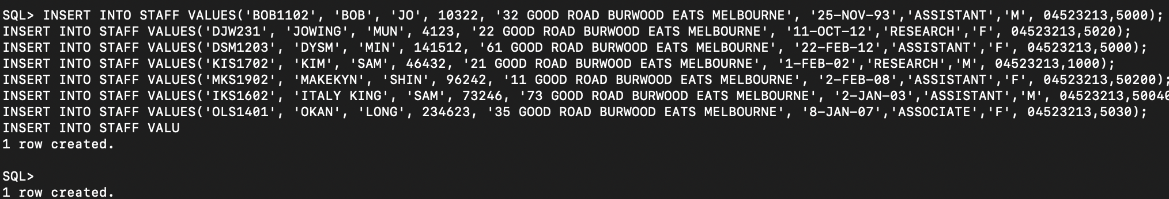

SELECT STAFF_NO, SURNAME, GIVEN, SECURITY_NUMBER, ADDRESS, BIRTH, RANK, SEX, PHONE,SALARY FROM STAFF;

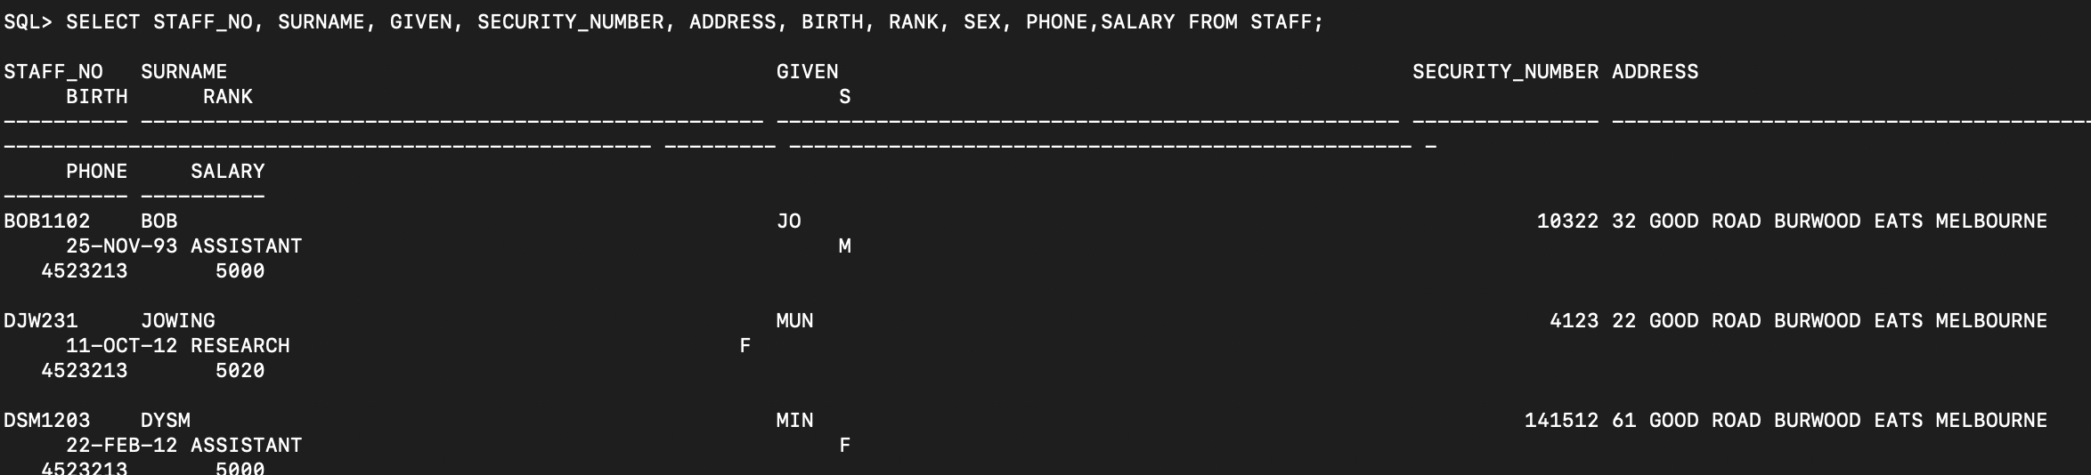

INSERT INTO STAFF_DEPARTMENT VALUES('BOB1102', 'B0003' );

INSERT INTO STAFF_DEPARTMENT VALUES('DJW231', 'B0033' );

INSERT INTO STAFF_DEPARTMENT VALUES('DSM1203', 'B0003' );

INSERT INTO STAFF_DEPARTMENT VALUES('MKS1902', 'C0011' );

INSERT INTO STAFF_DEPARTMENT VALUES('IKS1602', 'B0082' );

INSERT INTO STAFF_DEPARTMENT VALUES('BOB1102', 'B0033' );

INSERT INTO STAFF_DEPARTMENT VALUES('RIS1303', 'B0003' );

INSERT INTO STAFF_DEPARTMENT VALUES('RIS1303', 'B0082' );

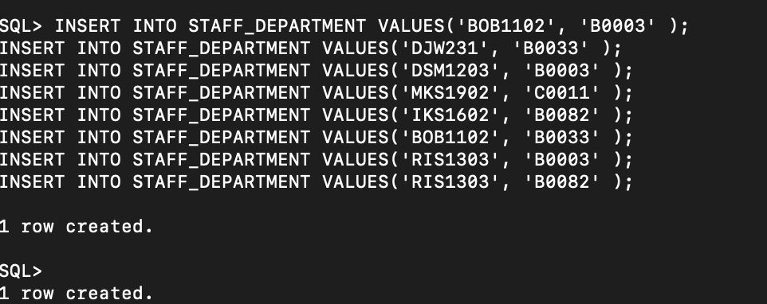

SELECT STAFF_NO,DEPARTMENT_NO FROM STAFF_DEPARTMENT;

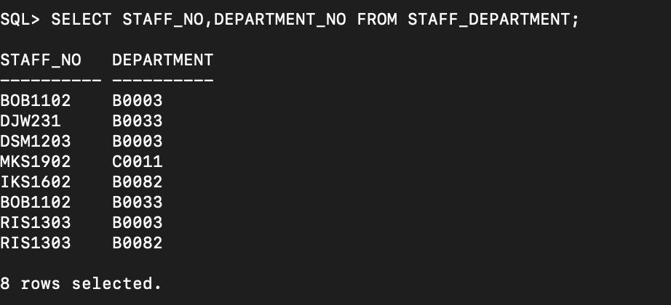

INSERT INTO STUDENT VALUES('STD1011', 'BOB','JONG','M','31 RINGWOOD STREET MELBOURNE','22-NOV-1991',1, NULL,NULL);

INSERT INTO STUDENT VALUES('STD1021', 'JACK','ZHENG','M','3 RINGWOOD STREET MELBOURNE','1-JAN-1989',1, NULL,NULL);

INSERT INTO STUDENT VALUES('STD1313', 'KIK','HHAN','F','42 GOOD STREET MELBOURNE','2-FEB-1985',2, NULL,NULL);

INSERT INTO STUDENT VALUES('STD2222', 'GIE','ZHONG','M','13 RINGWOOD STREET MELBOURNE','3-NOV-1996',1, NULL,NULL);

INSERT INTO STUDENT VALUES('STD1013', 'DAVE','CHEN','F','23 BOOD STREET MELBOURNE','4-JAN-1993',2, NULL,NULL);

INSERT INTO STUDENT VALUES('STD1511', 'MIKER','XIN','F','3 HARU STREET MELBOURNE','16-NOV-1992',3, NULL,NULL);

INSERT INTO STUDENT VALUES('STD4132', 'SARADA','JONG','M','4 WOOD STREET MELBOURNE','24-NOV-1993',1, NULL,NULL);

INSERT INTO STUDENT VALUES('STD6423', 'SUZUKI','NING','F','5 RINGWOOD STREET MELBOURNE','29-MAR-1991',3, NULL,NULL);

INSERT INTO STUDENT VALUES('STD5421', 'HASEKAWA','KIM','M','33 WUNAWA STREET MELBOURNE','12-MAR-1981',5, 'MASTER OF COMPUTING','BACHELOR OF DESIGN');

INSERT INTO STUDENT VALUES('STD3256', 'XIRANIE','LEE','M','33 NUNAWA STREET MELBOURNE','9-OCT-1971',5, 'MASTER OF MATH','BACHELOR OF ART');

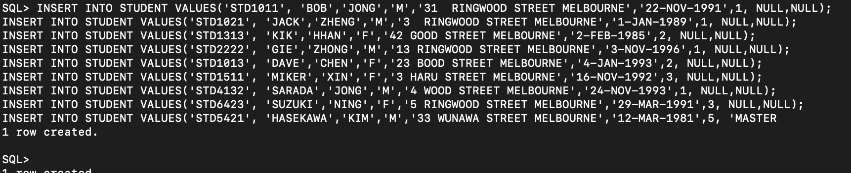

SELECT SID, SURNAME, GIVEN, SEX, ADDRESS, BIRTH, CLASS, DEGREE1, DEGREE2 FROM STUDENT;

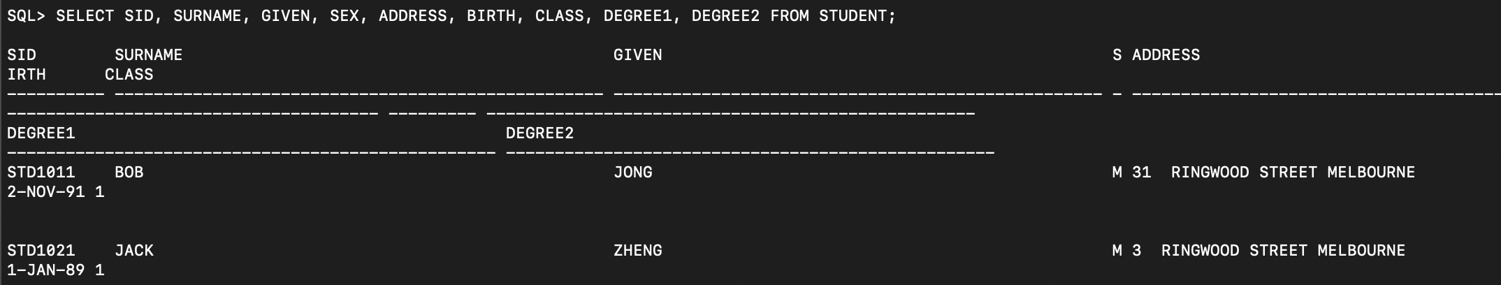

INSERT INTO COMMITTEE VALUES('COM201', 'BOB1102','STD5421');

INSERT INTO COMMITTEE VALUES('COM202', 'DJW231','STD3256');

INSERT INTO COMMITTEE VALUES('COM203', 'IKS1602','STD5421');

INSERT INTO COMMITTEE VALUES('COM204', 'BOB1102','STD3256');

INSERT INTO COMMITTEE VALUES('COM205', 'IKS1602','STD5421');

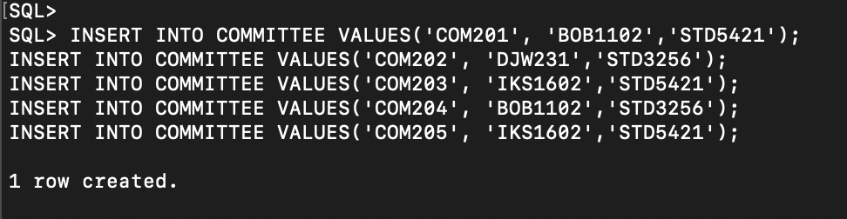

SELECT COMMITTEE_NO , STAFF_NO,SID FROM COMMITTEE;

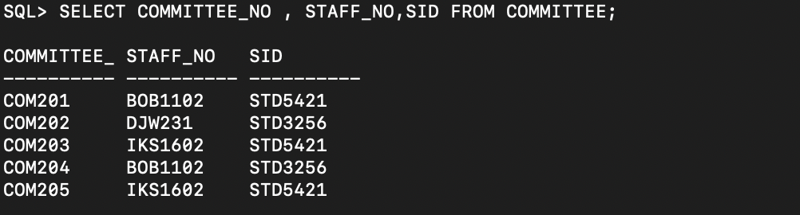

INSERT INTO SECTION VALUES('SEC101', 'A103','BOB1102','STD1011','B0003','C0011','1-JAN-2017','1-JAN-2016','WINTER',4);

INSERT INTO SECTION VALUES('SEC102', 'A103','KIS1702','STD1021','B0003','C0011','1-JAN-2017','1-JAN-2016','SUMMER',2);

INSERT INTO SECTION VALUES('SEC103', 'A104','IKS1602','STD1013','B0027','B0003','1-JAN-2015','1-JAN-2013','SPRING',1);

INSERT INTO SECTION VALUES('SEC104', 'A104','YIS1501','STD6423','C0011','B0003','1-JAN-2015','1-JAN-2013','SPRING',1);

INSERT INTO SECTION VALUES('SEC105', 'PY105','IKS1602','STD6423','B0027','C0011','1-JAN-2013','1-JAN-2012','AUTUMN',3);

INSERT INTO SECTION VALUES('SEC106', 'CHE302','OLS1401','STD1313','B0016','B0027','1-JAN-2013','1-JAN-2012','SUMMER',2);

INSERT INTO SECTION VALUES('SEC107', 'PHY321','RIS1303','STD1313','C0011','B0027','1-JAN-2013','1-JAN-2011','AUTUMN',3);

INSERT INTO SECTION VALUES('SEC108', 'MAT221','IKS1602','STD3256','C0011','B0003','1-JAN-2016','1-JAN-2011','SUMMER',2);

INSERT INTO SECTION VALUES('SEC109', 'COM213','RIS1303','STD3256','B0065','B0027','1-JAN-2016','1-JAN-2011','AUTUMN',3);

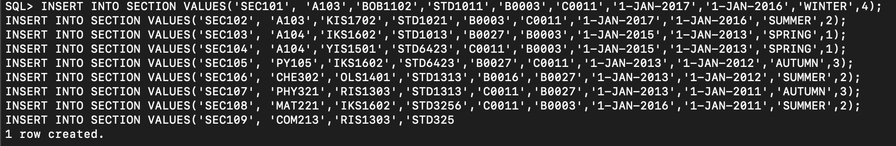

SELECT SECTION_NO,COURSE_NO,STAFF_NO,SID,MINAR_DEPARTMENT_NO,MAJOR_DEPARTMENT_NO,YEAR,OFFER_YEAR,QUARTER,QUARTER_NO FROM SECTION;

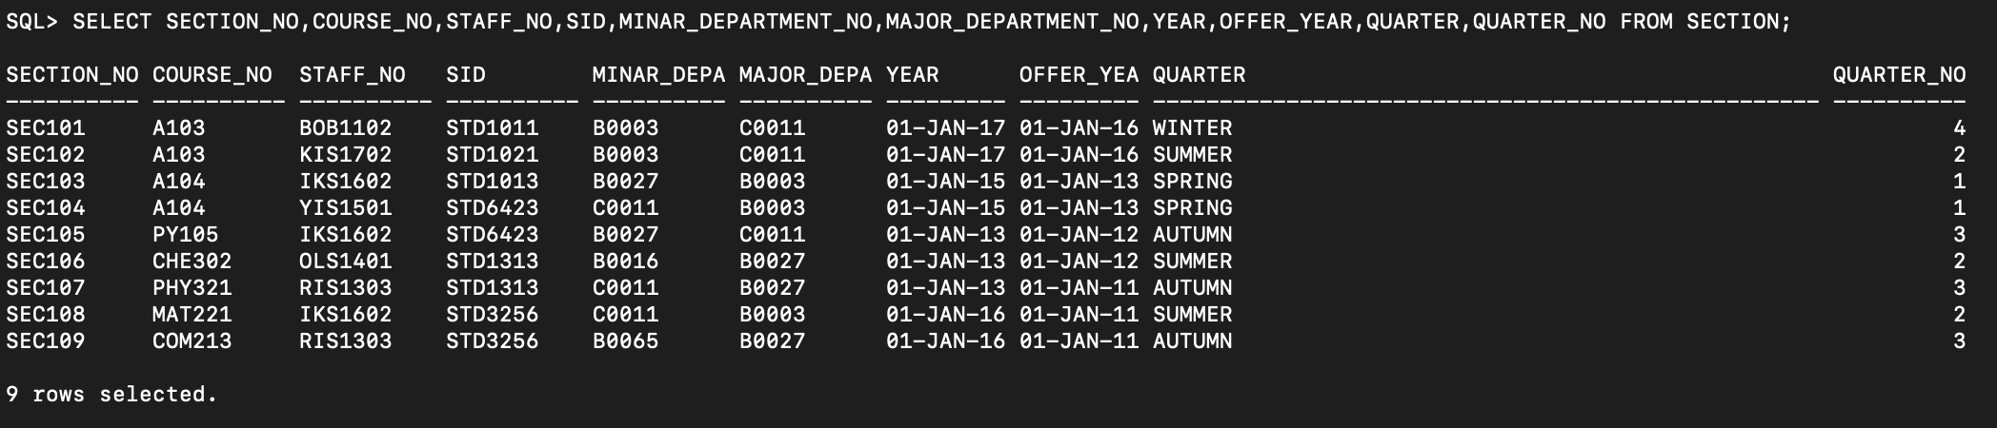

INSERT INTO TRANSCRIPT VALUES('TS101','SEC101','A103','STD2222',82);

INSERT INTO TRANSCRIPT VALUES('TS102','SEC102','A104','STD1313',94);

INSERT INTO TRANSCRIPT VALUES('TS103','SEC103','PY105','STD1013',74);

INSERT INTO TRANSCRIPT VALUES('TS104','SEC104','A103','STD1021',95);

INSERT INTO TRANSCRIPT VALUES('TS105','SEC105','PY105','STD1011',65);

INSERT INTO TRANSCRIPT VALUES('TS106','SEC106','A103','STD1511',56);

INSERT INTO TRANSCRIPT VALUES('TS107','SEC107','PY105','STD3256',77);

INSERT INTO TRANSCRIPT VALUES('TS108','SEC108','MAT221','STD4132',68);

INSERT INTO TRANSCRIPT VALUES('TS109','SEC109','PY105','STD6423',73);

INSERT INTO TRANSCRIPT VALUES('TS110','SEC101','MAT221','STD5421',83); 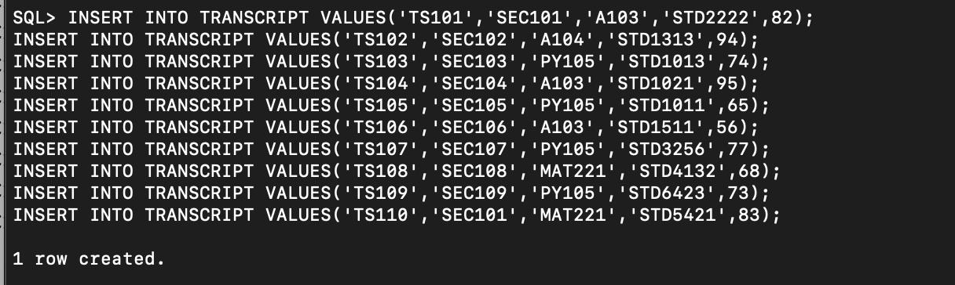

SELECT TRANSCRIPT_NO, SECTION_NO, COURSE_NO, SID, GRADE FROM TRANSCRIPT;

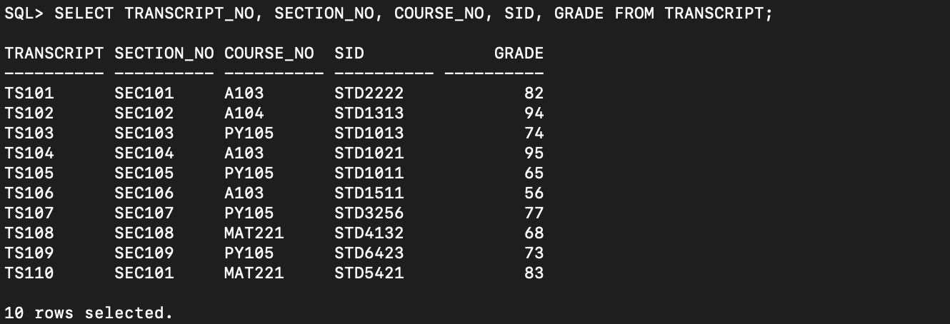

INSERT INTO GRANTS VALUES('GR101', 'AI RESEARCH', '18-FEB-2017', 'KCM', 'A0001');

INSERT INTO GRANTS VALUES('GR102', 'PYTHON RESEARCH', '3-OCT-2018', 'DDB', 'A0002');

INSERT INTO GRANTS VALUES('GR103', 'NEW LANGUAGE', '11-JAN-2015', 'GOOGLE', 'A0001');

INSERT INTO GRANTS VALUES('GR104', 'ENGLESH RESEARCH', '3-JAN-2015', 'WINS', 'A0002');

INSERT INTO GRANTS VALUES('GR105', 'GIOGRAPH RESEARCH', '21-OCT-2014', 'MICRO', 'A0001');

INSERT INTO GRANTS VALUES('GR106', 'WEATHER RESEARCH', '3-FEB-2013', 'NINTENDO', 'A0008');

INSERT INTO GRANTS VALUES('GR107', 'WATER RESEARCH', '21-OCT-2018', 'FKFK', 'A0003');

INSERT INTO GRANTS VALUES('GR108', 'WOOD RESEARCH', '11-JAN-2018', 'KCM', 'A0003');

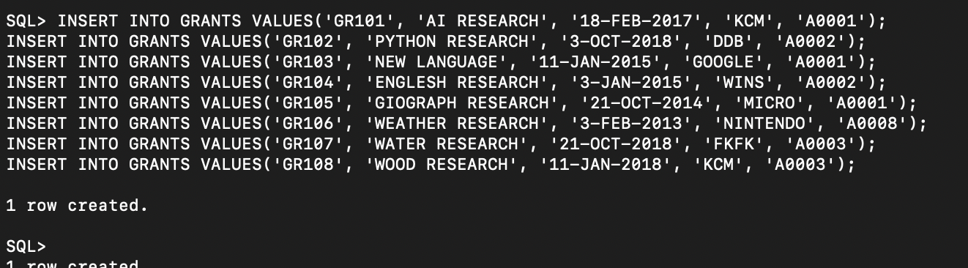

SELECT GRANT_NO, TITLE, START_DATE, AGENCY, COLLEGE_NO FROM GRANTS; 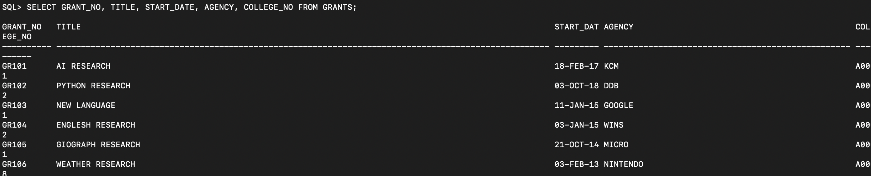

INSERT INTO SUPPORT VALUES('GR101', '18-FEB-2017', '18-FEB-2018','DJW231', 'STD1021');

INSERT INTO SUPPORT VALUES('GR101', '18-FEB-2017', '18-JAN-2017','DJW231', 'STD6423');

INSERT INTO SUPPORT VALUES('GR101', '18-FEB-2017', '18-OCT-2019','DJW231', 'STD6423');

INSERT INTO SUPPORT VALUES('GR101', '18-FEB-2017', '','DJW231', 'STD2222');

INSERT INTO SUPPORT VALUES('GR105', '18-FEB-2017', '18-MAR-2019','DSM1203', 'STD6423');

INSERT INTO SUPPORT VALUES('GR103', '18-FEB-2017', '','RIS1303', 'STD2222');

INSERT INTO SUPPORT VALUES('GR103', '18-FEB-2017', '18-OCT-2017','RIS1303', 'STD6423');

INSERT INTO SUPPORT VALUES('GR108', '18-FEB-2017', '','RIS1303', 'STD2222');

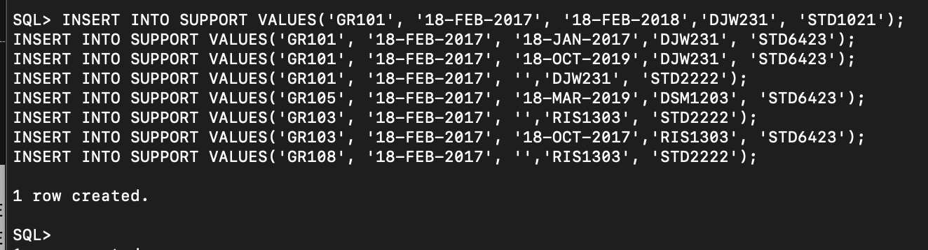

SELECT GRANT_NO, START_DATE, END_DATE, PRINCIPAL_INVE, SUPPORT FROM SUPPORT; 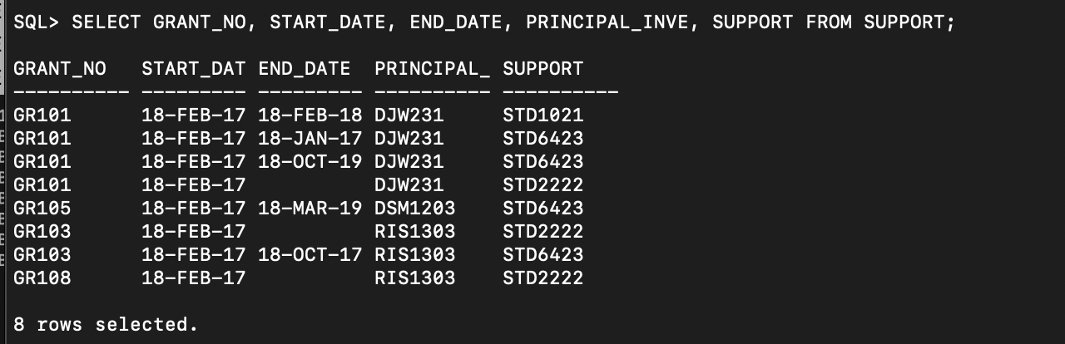

Q2:

alter table student add (phone_number number(20));

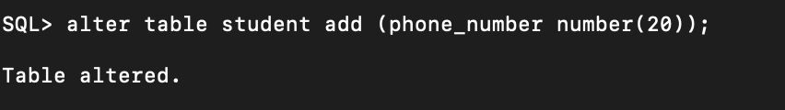

Q3:

update staff set salary = salary * 1.05;

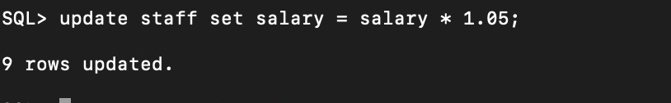

Q4:

select course_NO, name from course where department_NO = 'C0011';

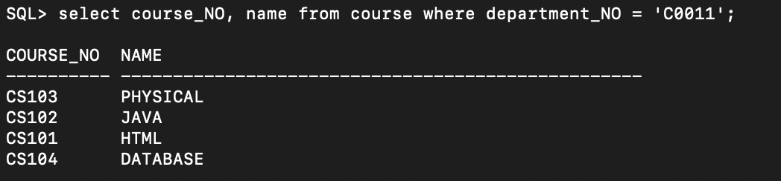

Q5:

select SID as "student number",

SURNAME || ', ' || GIVEN AS "FULLNAME",

FLOOR((SYSDATE - birth)/365.25) AS "age" from student

where FLOOR((SYSDATE - birth)/365.25) BETWEEN 18 and 21;

